# Just a normal day of Jack’s life

## Story

Jack is a teenage boy who is being chased by drones sent by a mad scientist. He has to destroy the drones and help the good scientist to find about the compound the mad scientist is going to create. The drone is attacking him. He has to doze all the drones and reach the scientist. Once he gives the element that the scientist wants, he will get a certain buff for his gun for certain.

Compounds: Those which we study in from grade 6-10.

Game components

## Map:

There will be a map of the whole city where the player is allowed to go. From this map, our player will learn about the east, west, north, and south direction and also learn how to see the map.



## Drones:

These are the drones send by the mad scientist to stop the player from revealing his evil idea to the world. These drones will attack player everywhere in the town.

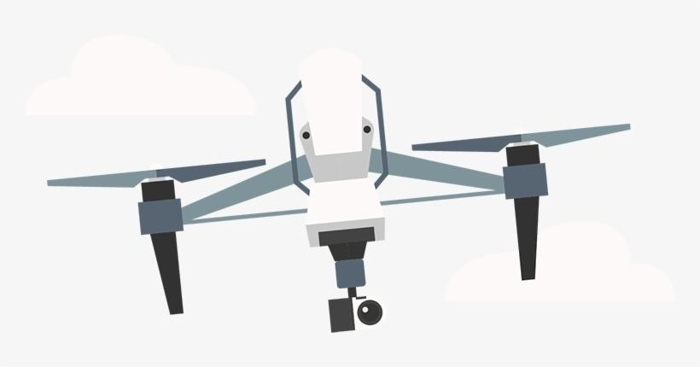

## Blaster:

This baster is a laser gun which will help player to destroy the drones

## Flying boots:

These are the boots given by the good scientist to the player. These boots help player to fly and fight drones.

## Jack:

Jack is a teen boy. He is the main character of the story. He is helping the good scientist to find about the evil plan of the mad scientist. He is the only playable character in this game.

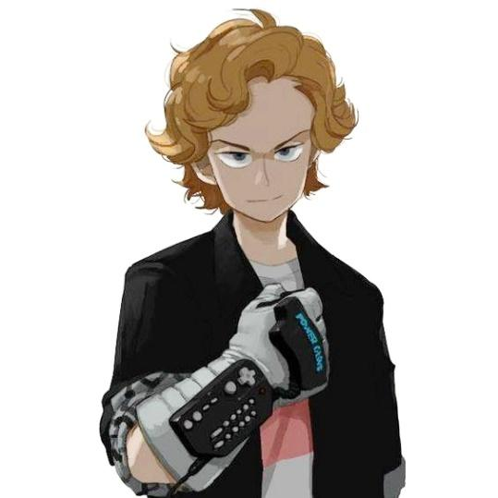

## Game world

First, Jack will go to the house of bad doctor secretly and see the chemical formula written in the board. While doing that the bad doctor will see him and send his drones to hunt down the Jack.

On the way to the good doctor, he will collect the letter related to the chemical formula on the way. The drone will be unlimited and keep spawning in greater number every 10 seconds. Every time he gives the formula, he will get buff for certain amount of time (30 sec buff- 45 mins buff).

When player reach inside the good doctor’s house the drone won’t be able to enter there. He will give the chemical formula to the good doctor by dragging and dropping the letters he collected before.

## Goal

### Initial Goal

To destroy drones.

### Final Goal

To give formula to scientist and survive.

## Obstacle

Drones will shoot you lasers and when your hp is low you will die. If your give wrong formula to scientist, he will send you back the get the right formula.

## Lifeline

Player will be given 5 lifelines.

## Unpredictability

Random buff bull be given to the player as bonus if he/she survives for every 2 minutes.

Hp buff

Double laser buff

Double gun buff

Score x2

Laser dmg x2

Piercing laser for 30 second, etc

## Interaction

We can use the player like Minilimilita when fighting drones